



MANUAL TESTING FOR OPEN SOURCE

CURA HEALTH CARE SERVICE





**Project submitted by:-**

**TEAM LEADER: Mopuri Shreyareddy**

**TEAM MEMBERS:**

**1. Mothukuri Harsha Vardhan**

**2. Mamidi Srikanth**

**3. Mummareddy Anilkumarreddy**

**4. Palukuri Manoj Kumar**

Open Source Cura Health Care Service Manual Testing

Amidst the COVID-19 pandemic, an international task force of designers, engineers, medical professionals, and military experts have joined forces to work on CURA, an open-source project aimed at capacity building in Intensive-Care Units (ICU). The first prototype of CURA, whose name stands for Connected Units for Respiratory Ailments (and also “cure” in Latin), is currently being built in Italy, with the sponsorship of European bank UniCredit. It uses repurposed shipping containers to create plug-in biocontainment pods that can be quickly deployed in cities around the world, promptly responding to the shortage of ICU space in hospitals and the spread of the disease.

# Open Source Cura Health Care Service Home Page:

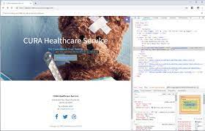

Link: https://www. Open Source Cura Health Care Service.com/en

**Project Flow:**

* User can user Open Source Cura Health Care Service platform
* User can register once and continue seeing Open Source Cura Health Care Service business maintenance
* User can login as admin & front-end/user resource and monitor the business
* User can also configure dashboard all setup related to Open Source Cura Health Care Service business

# Modules Structure:

We have different modules in this all the modules are listed below,

* PRODUCT
  + Store demo
  + Showcase
  + Features
  + Why for developers
  + Why for store owners
  + Industries
* DOWNLOADS
  + Download nopCommerce
  + Marketplace
  + Translations
  + Copyright removal key
  + Mobile application
  + Web API
* SUPPORT&SERVICES
  + Training
  + Documentation
  + Community forums
  + Premium support services
  + Request a quote
  + Contact us
* PARTNERS
* CHANGE LANGUAGE
* GET STARTED
* CART
* ACCOUNT
  + Log in
  + Register
* GET STARTED
* VIEW DEMO

# Milestone 1: PRODUCT Module

**PRODUCT section for various options with Store demo, Showcase, Features, Why for developers, why for store owners, Industries**

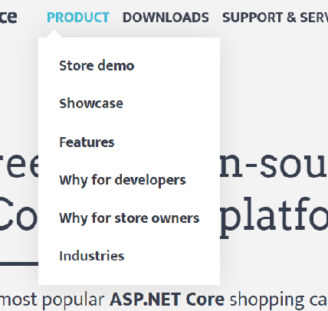

Link: https://www.Open Source Cura Health Care Service.com/en

## Activity 1: Verifying Store Demo sub module when user clicked on it to see page navigation

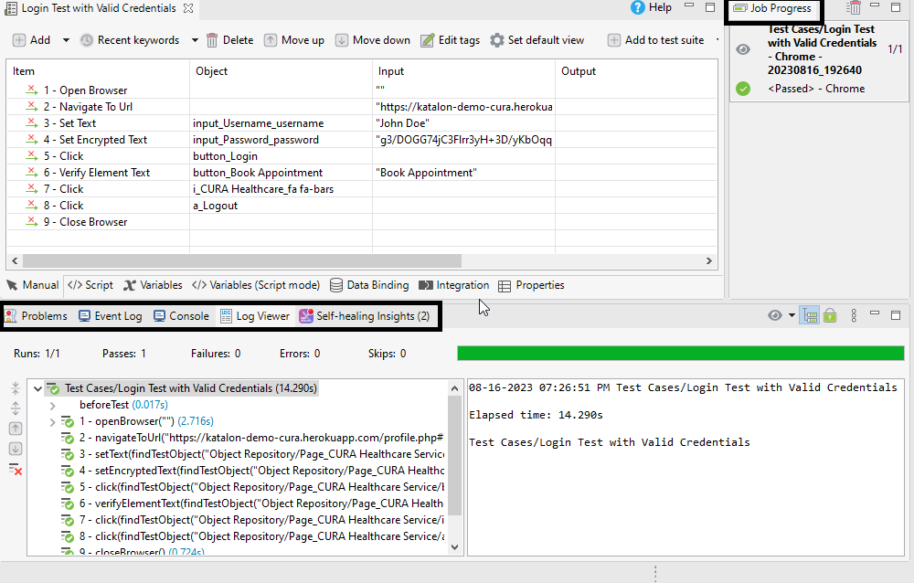

Link: https://www. Open Source Cura Health Care Service.com/en/demo

## Activity 1.1: Verifying all the text available on screen

Verifying various text available on the screen to make sure all data is represented correct and verify Admin area, Frontend links

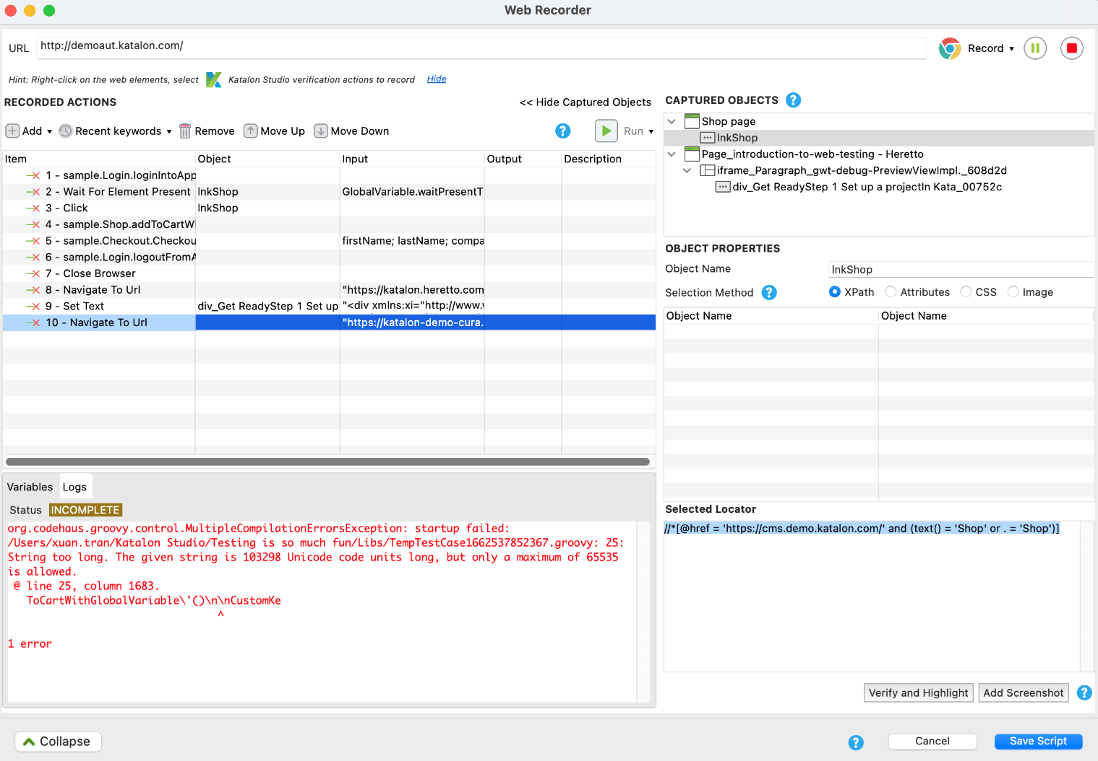

Link: https://www. Open Source Cura Health Care Service .com/en/demo

## Activity 1.2: Verifying Admin area page functionality the labels and buttons colors, font , alignment etc...

Link: https://admin-demo. Open Source Cura Health Care Service.com/login?ReturnUrl=%2Fadmin%2F

## Activity 1.3: Verifying Frontend button functionality after clicking it will navigate to other page where we have a chance to view different options available for an end user

## Your All-New API Testing Experience with Katalon Studio 5.8

## 

Link: https://demo. Open Source Cura Health Care Service.com/

## Activity 1.4: Verifying link functionalities for each individual button , font, alignment, spellings

## Create test cases with Record and Playback in Katalon Studio | Katalon Docs

Link: [https://www. Open Source Cura Health Care Service.com/en/demo](https://www..com/en/demo)

Verifying each and every button, links functionality, upon clicking each link is it navigating to desired links are not.

## Activity 1.5: Verifying links are navigating to desired page

In simple words, when a user clicks on sub module links it has to navigate to desired link and show the desired pages accordingly.

# Milestone 3: Verifying DOWNLOADS module

DOWNLOADS section for various options with Download nopCommerce, Marketplace, Translations, Copyright removal key, Mobile application, Web API

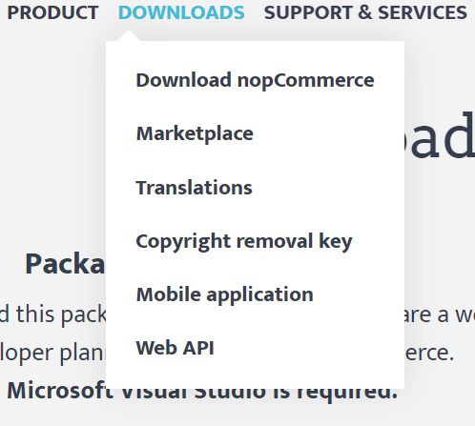

Link: https://www. Open Source Cura Health Care Service.com/en/demo

## Demystifying Test Case Creation in Katalon Studio: Record, Manual, and Script Modes / Blogs / PerficientActivity 1: Verifying Download Open Source Cura Health Care Service Option from DOWNLOADS module

Link:  [https://www. Open Source Cura Health Care Service.com/en/download-nopcommerce](%20https://www..com/en/download-nopcommerce)

## Activity 1.1: Verifying link functionalities for each individual buttons

## Verifying each and every button links functionality, upon clicking each link is it navigating to desired links are not

Link:  [https://www. Open Source Cura Health Care Service.com/en/download-nopcommerce](%20https://www.%20Open%20Source%20Cura%20Health%20Care%20Service.com/en/download-nopcommerce)

## Activity 1.2: Verifying links are navigating to desired page

In simple words, when a user clicks on sub module links it has to navigate to desired link and show the desired pages accordingly.

# Milestone 4: Verifying SUPPORT & SERVICES Module

# 

Link:  [https://www. Open Source Cura Health Care Service.com/en](%20https://www.%20Open%20Source%20Cura%20Health%20Care%20Service.com/en)

## Activity 1: Verifying Training Option from SUPPORT & SERVICES module

## 

Link:  [https://www. Open Source Cura Health Care Service.com/en/training](%20https://www.%20Open%20Source%20Cura%20Health%20Care%20Service.com/en/training)

## Activity 1.1: Verifying link functionalities for each individual button

Verifying each and every button links functionality, upon clicking each link is it navigating to desired links are not.

Link:  [https://www. Open Source Cura Health Care Service.com/en/training](%20https://www.%20Open%20Source%20Cura%20Health%20Care%20Service.com/en/training)

## Activity 1.2: Verifying links are navigating to desired pages.

In simple words, when a user clicks on sub module links it has to navigate to desired link and show the desired pages accordingly.

# Milestone 5: Verifying PARTNERS Module

Link: https://www. Open Source Cura Health Care Service.com/en/partners

## Activity 1.1: Verifying link functionalities for each individual button

Verifying each and every button links functionality, upon clicking each link is it navigating to desired links are not.

Link: https://www. Open Source Cura Health Care Service.com/en/partners

## Activity 1.2: Verifying links are navigating to desired pages

In simple words, when a user clicks on sub module links it has to navigate to desired link and show the desired pages accordingly.

# Milestone 6: Verifying CHANGE THE LANGUAGE Section

# 

Verify User can change the language from ‘Language ’section.

Link: https://www. Open Source Cura Health Care Service.com/en/download-nopcommerce

# Milestone 7: Verifying user can search orders, sales etc. functionality with admin login

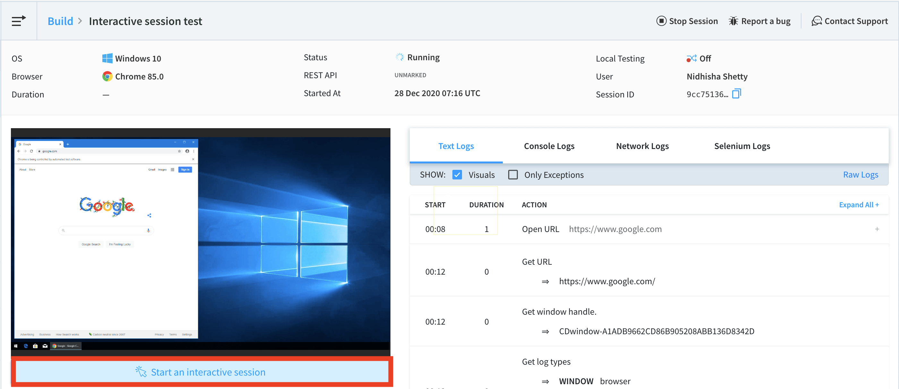

Link: https://admin-demo. Open Source Cura Health Care Service.com/admin/

## Activity 1.1: Verifying search functionality by entering orders text in search box and hit search button to get results related to orders

## Debugging Options for Selenium Testing | BrowserStack Docs

Link: https://admin-demo. Open Source Cura Health Care Service.com/admin/

## Activity 1.2: Verifying Different menu options available in admin login and user can see orders, shipments, return requests, recurring payments, Gift cards etc..

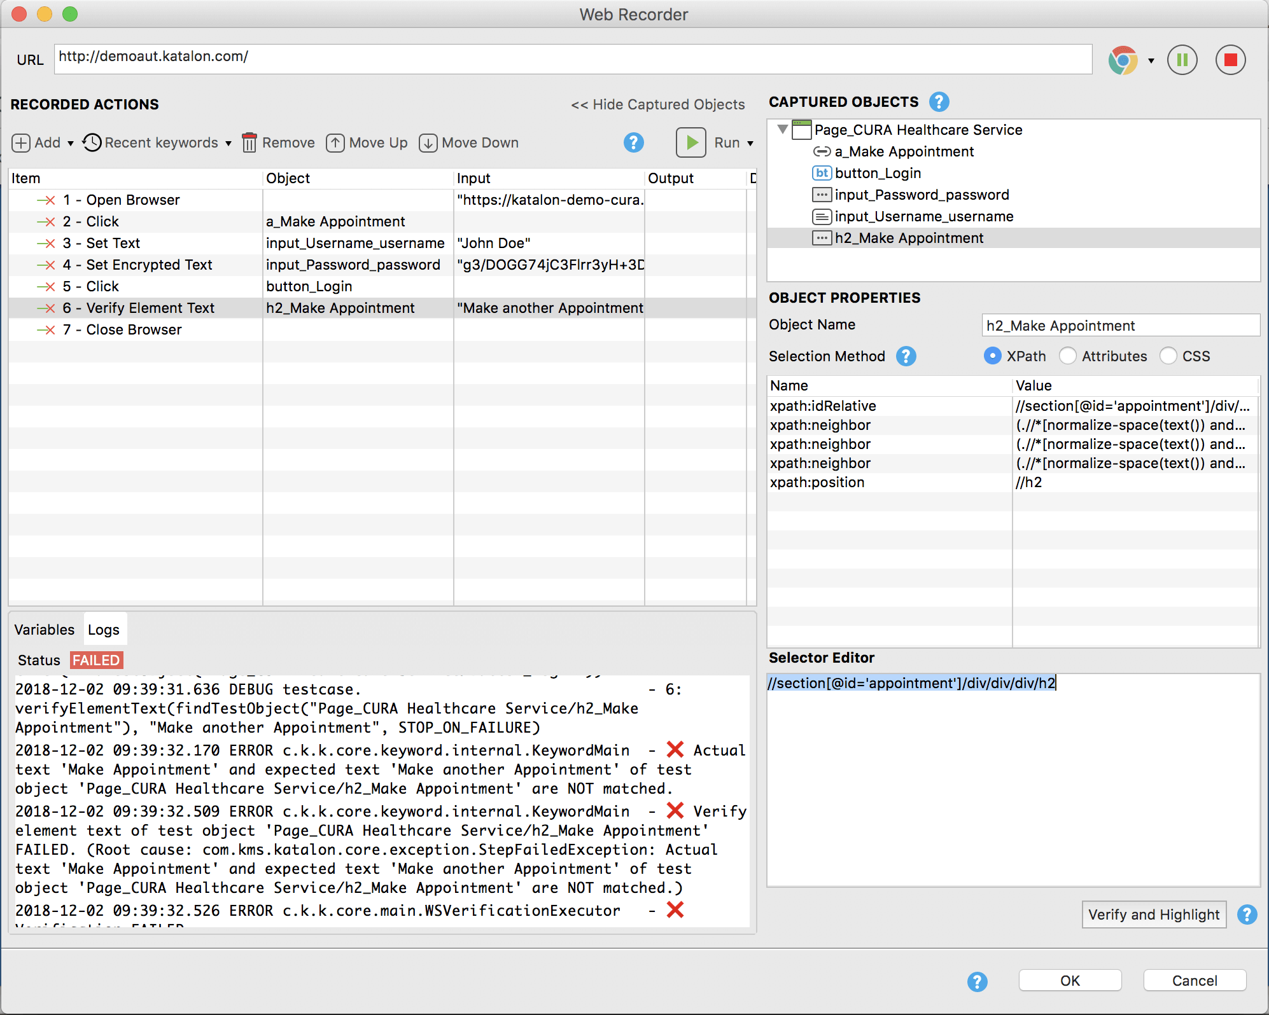

Link: https://admin-demo Open Source Cura Health Care Service.com/admin/

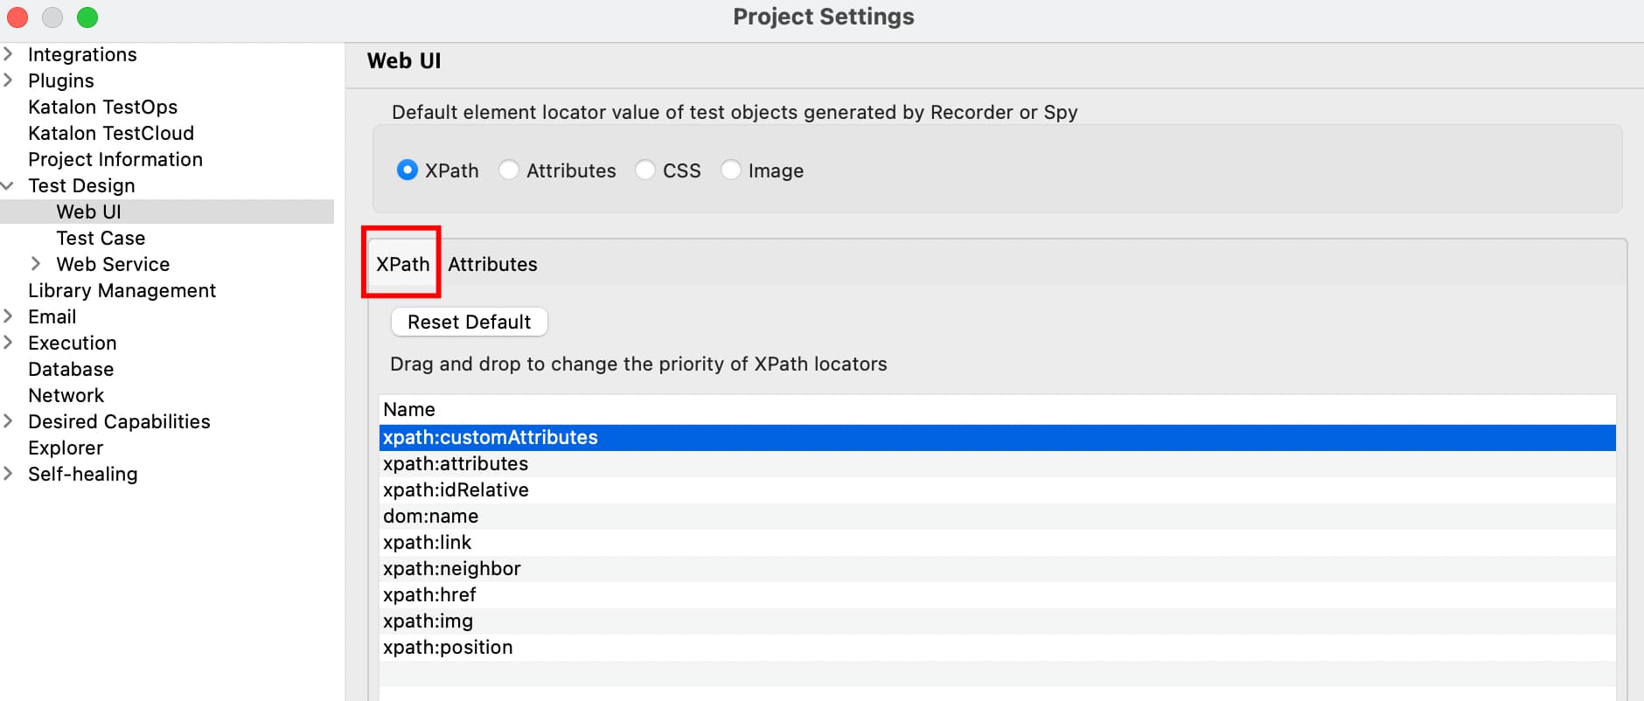

**Final Testing Areas:**

1. Test the Home page elements color, font, alignment, design
2. Test the admin area login functionality
3. Test the Front-end login functionality
4. Test get started button functionality
5. Test the user can enter valid email & password
6. Test the user can enter invalid email & password
7. Test the main modules and sub modules functionality
8. Test user can search from global search area after login as an admin
9. Test sub modules pages are loading properly or not
10. Test user can logout successfully